Israeli Stereotypes
Created by: Michaela Sadinsky, ECRUSY
with help from Maor Cohen and Amarel Gofer, BDBIBA shinshinim

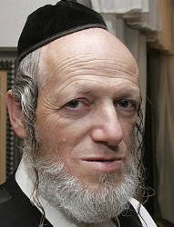
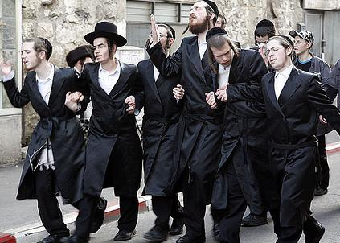

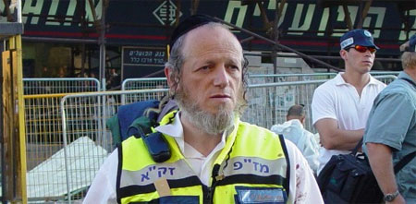
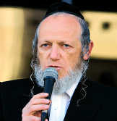
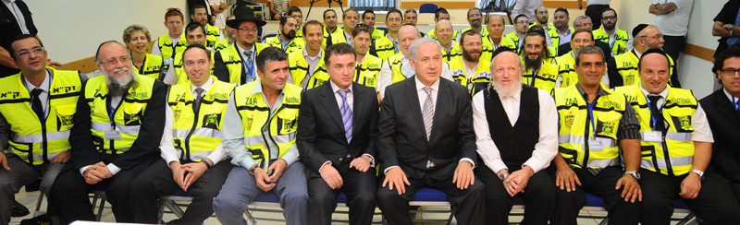

Hassidim - Part 1 (show first page of pictures)
- What do you first think of when you see the two previous pictures?
- What do you think is these people’s economic standing/home life/future?
- If you encountered one of these people in the street, what would you think/say?
- What do you think these people’s position is about Israel and Zionism?
Part 2 (show second page of pictures)
- Who is this?
- Ask a USYer to read the following:
This is Yehuda Meshi-Zahav. He is an Orthodox Jew, having been raised in Meah Shearim in Jerusalem. As a child, he was taught to oppose Zionism, and was arrested multiple times for organising protests against Zionism. However, in 1989, Yehuda witnessed the aftermath of an Islamic attack on a Jerusalem bus, and realised that if terrorists do not discriminate between Jews, then neither should he.
Along with Rabbi Moshe Aizenbach and Rabbi Zvika Rosental, Yehuda started ZAKA, a series of voluntary community emergency response teams in Israel, and now across the world, that aid in the identification of victims of terror, road accidents and other disasters, first aid and rescue services, searching for missing persons, and preparing bodies for proper burial. ZAKA works closely with the Israeli Police to perform these tasks.
Most of ZAKA’s volunteers are Orthodox Jews. The founders of ZAKA prefer to call their work Chesed shel Emet (Grace of truth), because they are dedicated to ensuring that the bodies of Jewish victims are buried according to Halakha. However, they do not just perform these acts for Jews. After acts of terrorism, ZAKA volunteers also collect the bodies and body parts of non-Jews, including suicide bombers, for return to their families.
In 2010, there were 1500 ZAKA members. Presently, there are 1650 members. All of these members are trained as paramedics and in first aid and are on call 24/7, including Shabbat. There are two units made up of Bedouin, Muslim, and Druze volunteers who will respond to calls on Shabbat and who serve Israel’s non-Jewish communities, primarily Bedouin in the Negev and Druze in the Galilee.
ZAKA volunteers have provided assistance in the following countries:
- 2004 and early 2005 – Thailand, Sri Lanka, India, and Indonesia in the aftermath of the 2004 Indian Ocean earthquake
- February 2007 – a 10-person search and rescue team was sent to Paris to search for a missing IDF official
- November 2008 – India, following the terrorist attacks that included a Chabad centre
- 2010 – Haiti, aiding in search and recovery efforts after the Haiti earthquake
- March 2011 – Japan to aid in search and rescue after the earthquake and subsequent tsunami
Part 3
- Did your opinion on this group of people change? If so, how?
- What assumptions may you have made when you first saw the pictures?
- What can we learn from Yehuda Meshi-Zahav’s story?
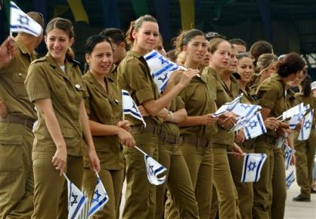

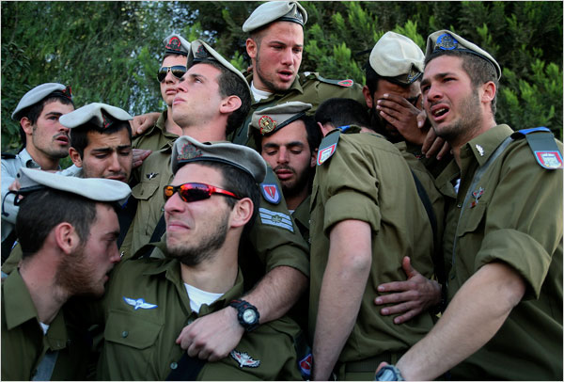

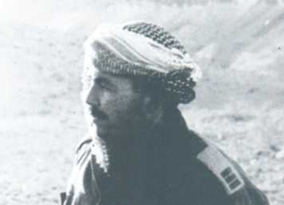
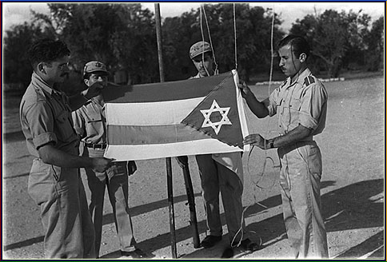
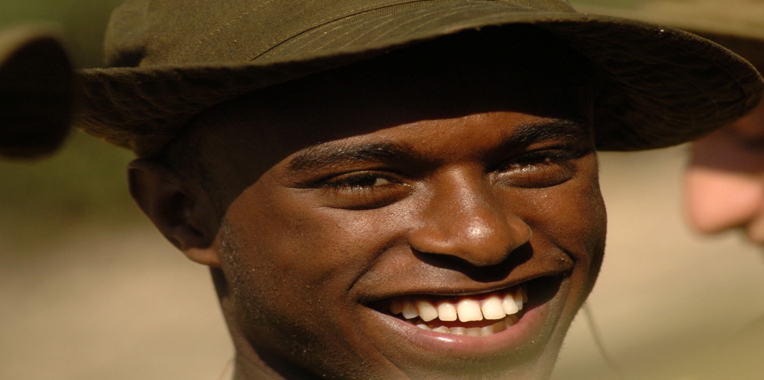

IDF - Part 1 (show first page of pictures)
- What do you first think of when you see the two previous pictures?
- What do you think is these people’s economic standing/home life/future/religion?
- If you encountered one of these people in the street, what would you think/say?
- What do you think these people’s position is about Israel and Zionism?
- Would you hold these people higher than other groups in Israel? If so, who?

Part 2 (show second page of pictures)
- Who are these people?
- Ask a USYer to read the following:
Lieutenant Colonel Amos Yarkoni was born as Abd el-Majid Hidr in the Bedouin village of Na’ura, in the Gilboa region of northern Israel, to a Muslim family. He was a legendary officer in the Israel Defense Forces and one of six Israeli Arabs to have received the IDF’s third highest decoration, the Medal of Distinguished Service.
In 1936, after sabotaging the TAP Line, an oil pipeline running from Iraqi oilfields to Haifa, Hidr had a dispute with the group and fled to a Jewish area of what was then referred to as Palestine, where the 16 year old was sheltered by Jews. It was there that he met Moshe Dayan and developed contacts in the Haganah. They kept in touch until the War of Independence. In December 1947, he joined the newly created IDF, and changed his name to Amos Yarkoni.
‎ Yarkoni served in a number of units during the war, ending up in the Minorities Unit, and proved to be an excellent tracker and patrolman. In 1953, he passed the Officer’s Course and went on to become the Commanding Officer of the Unit. Yarkoni’s skills were crucial to the IDF and in 1955, he helped to form the IDF tracking and counter-terrorism unit, named “Shaked”, meaning almond, but also an acronym for the “Guardians of the Southern Border”.
The Shaked unit included both Jews and non-Jews, yet when it came to Bedouins, Amos was careful to accept only Bedouins from northern Israel, so that they wouldn’t have to fight against their own tribe. Many Israelis did not know that Amos Yarkoni was not Jewish, assuming that he was a Jew from an Arab country. He was based in the Negev for several years and was involved in countless operations. He was wounded many times, including losing his right hand in 1959 and a badly wounded leg in an explosion. During the Six-Day War, Yarkoni served on the Sinai front, and retired from the IDF in 1969.
On February 7, 1991, Amos Yarkoni died at the age of 71, after battling cancer. It was requested that he be buried in a military cemetery, despite the fact that as a retired soldier, he was technically ineligible for a military burial. However, the request was approved, and his funeral was attended by the President of Israel, Chaim Herzog, political and military leaders, former members of the Shaked Battalion and many other Israelis.
The face of the IDF has been changing since Independence. More and more Druze, Bedouin, and other Arab Israelis are joining the military, eager to show their dedication to Israel. Ethiopian Jews are joining the army when they immigrate to Israel. The IDF even includes deaf and hard-of-hearing soldiers. As well, volunteers from all over the world come to Israel to serve in the IDF.
Part 3
- Did your opinion on this group of people change? If so, how?
- What assumptions may you have made when you first saw the pictures?
- What can we learn from Amos Yarkoni’s story?
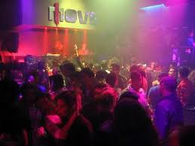

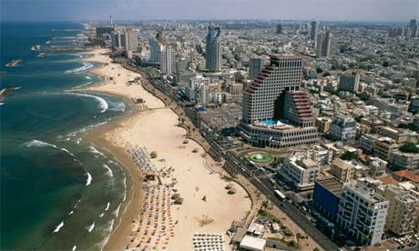
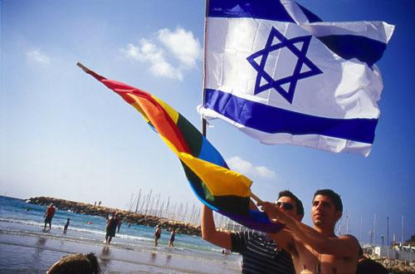
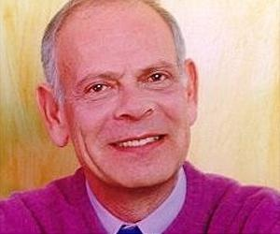
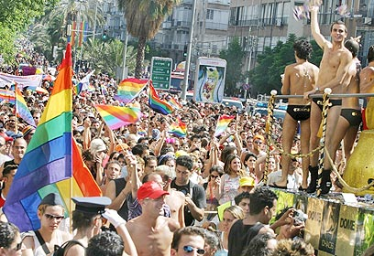

Tel Aviv - Part 1 (show first page of pictures)
- What do you first think of when you see the three previous pictures?
- Where do you think these people live?
- What do you think is these people’s economic standing/home life/future/religion?
- If you encountered one of these people in the street, what would you think/say?
- Would you hold these people higher than other groups in Israel? If so, who?
Part 2 (show second page of pictures)
- Who are these people?
- Ask a USYer to read the following:
Professor Uzi Even is a professor of Chemistry and Tel Aviv University and a former member of the Israeli Knesset. He was born in Haifa to eastern European Jewish immigrants. He received a Bachelor’s of Science degree and a Master’s of Science degree in Physics from Technion University and a Ph.D at Tel Aviv University.
In 1993, Even reported to the Knesset that he had been removed from the IDF and lost his security clearance after the IDF had discovered that he was homosexual. His testimony in front of Yitzhak Rabin’s government led to the changing of the law and regulations, allowing homosexuals to serve in the army in any position, including one requiring high security clearance. As well, in 1995, Even challenged his employer, Tel Aviv University, to grant his partner spousal rights.
As a member of Meretz (now known as Meretz-Yachad), an extremely left-wing political party in Israel, Even was very close to being elected to the Knesset in 1999, but only became a member of Knesset when Amnon Rubinstein resigned in 2002. This made Even the first openly homosexual member of Israeli Knesset in history. In 2006, Even left Meretz and joined the Labor Party, recognising that Labor stressed equality to all citizens in its election manifesto.
On March 10, 2009, the Tel Aviv family court ruled that Even and his now ex-partner, Amit Kama, could legally adopt their 30-year-old foster son, Yossi Even-Kama. They were the first same-sex male couple in Israel who received legal permission and acknowledgement of their ability to adopt.
In a survey, co-sponsored by American Airlines, Tel Aviv received 43% of votes, identifying it as the number one “gay city” in the world (New York City followed with 14%, and then Toronto with 7% of votes). According to Asaf Zamir, Tel Aviv’s deputy-mayor, almost 17% of the city’s population considers themselves to be homosexuals, causing Tel Aviv to boast one of the highest homosexual populations in the world.
This past summer, 100,000 Israelis and an additional 5,000 tourists took part in the annual Tel Aviv Gay Pride Parade, supporting gay rights and equality. Activities and parties continued throughout the month of June, a month which has been specified as “Gay Pride Month”.
Part 3
- Did your opinion on this group of people change? If so, how?
- What assumptions may you have made when you first saw the pictures?
- What can we learn from Uzi Even’s story?

